The Lyme Regis Museum has a gallery on its top floor called the Rotunda, which regularly holds art exhibitions. The Museum is always planning forward for these and we are delighted that you have shown interest in hosting a showcase at the Rotunda.
The ground rules are simple:
• We are looking for solo or joint exhibitions with a theme or overriding cohesiveness of subject matter or medium.
• The space is limited in size, so you will need to be selective (see below image).
• While we can offer advice, the setting up, taking down and making good of the space for the next artist will be your responsibility.
• There are three display cases in the centre to be utilised as space for ancillary materials (sketchbooks, items relevant to your theme, etc). Two are covered by a perspex box. The one ‘open’ shelf is useful for visitors’ books, leaflets etc, but everything on it must be light or tied down as the shelf sits over a space open to the lower floors!
• Since no one stewards these exhibitions, you will need to ensure nothing is re-moveable and provide a welcome text, introducing yourself, your work and the exhibition’s theme.
• Sales will be dealt with by the Museum shop from the price list you provide them, and the shop can also sell your cards. You will need to take into account in setting your prices that the Museum will be taking 30% commission on artwork sales and 50% on card sales.
• While the promotion and publicity about the exhibitions will be handled by the Museum’s publicist Eleanor Wentzell, a leaflet would a useful tool to aid promotion and should be produced by the artist.
• Each exhibition runs for about 8-12 weeks. We will take into account your date preferences, but the final decisions as to who exhibits when will be up to us.
What we need from you:
A one-page proposal for your exhibition by email to the address below. Include an exhibition title, summary of theme, name(s) of artist(s) involved, contact details, and your preferred exhibition dates. You should also attach 2-4 images to offer an idea of the work you are proposing to show.
We will review the proposals and let you know the decision on your application. Any questions, please contact us.
Bridget Houseago, Director bhouseago@lymeregismuseum.co.uk

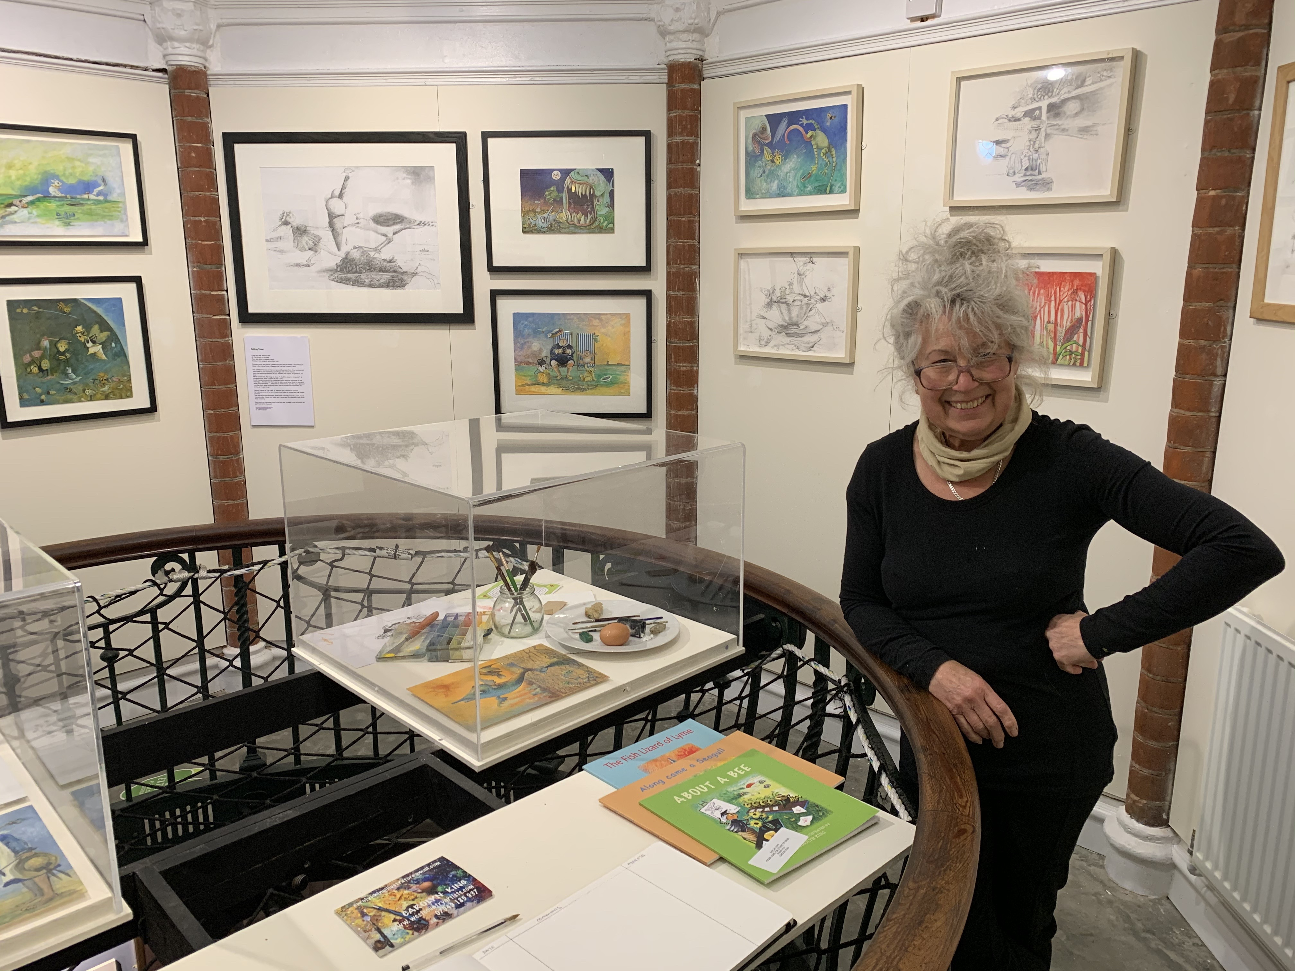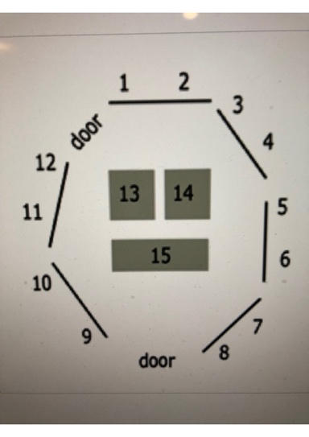
Carolyn King at her Rotunda show + layout of Rotunda.

